12th Annual Student  Scholarship Conference  Tuesday, March 13, 2018 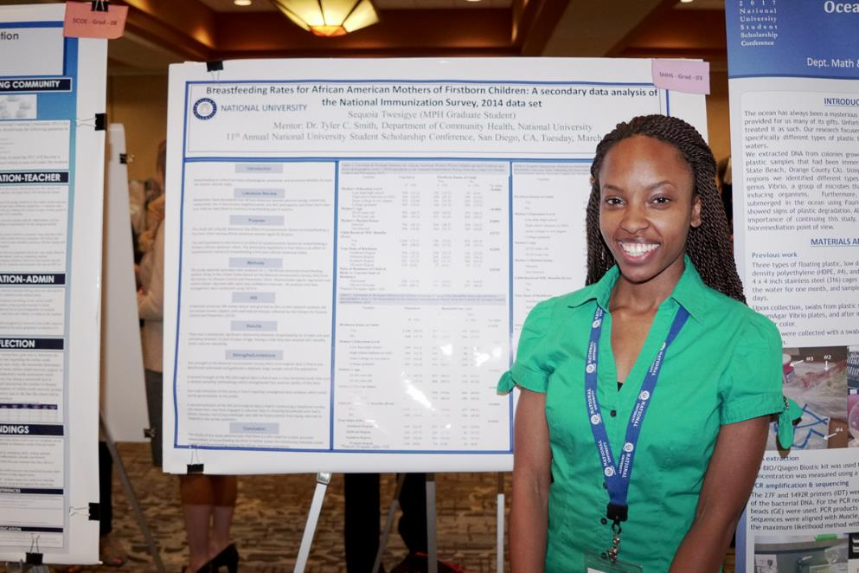  Undergraduate, graduate students and alumni* from NU and NU System affiliates from all disciplines are invited to submit your student thesis results, capstone findings, class projects, learning innovations, research findings or other creative scholarly work. The conference attendance is open to all students, alumni, faculty, friends, family, and the community.  Authors are required to provide a presentation for a maximum of 5 minutes of their individual or group work, either in-person or through a live video presentation. Zoom presentation will also be available for NU system students. A judging panel of Research Council members and other faculty of broad expertise will ask questions regarding work presented in the poster and score presentations under various categories using a common rubric. Awards will be given to outstanding contributions in the undergraduate and graduate categories from each school/college. Presenters must be available during judging periods to be considered for an award. Faculty mentors whose students participate in the conference will also be recognized. Financial awards will also be given to the overall best undergraduate and graduate student posters!  Submission Guidelines:  - Work must have been done exclusively by a current NU System student or group of students.  - Work must be completed under faculty supervision or mentorship.  - Not previously submitted for a conference presentation.  - Must have proof of IRB waiver or approval (An official determination from IRB is required for all submissions, see below for steps on completing this requirement)  - If applicable, authors must include an approved NU Site/Subjects Request Form when using NU data or NU students, faculty, and/or staff for research purposes.  Submissions open: Tue., 1/19/2018  Close: Monday 2/12/2018 Acceptance: Friday 2/23/2018 |  | Undergraduate & Graduate Awards  Faculty  Mentorship  Networking  Enhance Student Resume  Current Students  & Alumni*  Travel Stipend**  Deadline 2/15/2018  *Degree conferral 3/31/17  **Competitive Stipends  MarriotT  La JoLLA  4240 La Jolla Village Drive  La Jolla, CA 92037  Set-up &  breakfast: 7:30 - 9:00am  Judging: 8:30 -10:00am  Networking: 10:00-12:00pm  Awards: 12:00 pm-12:30pm  Lunch: 12:30pm
Submissions Procedure via email to SSC co-chairs (by Faculty sponsor only):
NU Copy/postal has kindly agreed for printing and mounting of 30” x 40” posters. The deadline for submission of projects directly to Co-Chairs via email is February 15, 2018. Please attach required documents in an e-mail by 11:59PM Pacific Time, February 15th, 2018. In your message, include a copy of your IRB approval, Faculty Mentor Letter of Support and the submission form to Student Scholarship Co-Chairs Christopher Hendrickson (chendrickson@nu.edu) and Wayne Padover (wpadover@nu.edu). Please include the subject: “2018 Student Scholarship Conference Submission” in your e-mail message.
Student and Faculty authors will be notified of project approval by February 25th, 2018 upon which Faculty Sponsors presenting posters are asked to again email Co-Chairs final copy of their Powerpoint or PDF file by March 3, 2018 (11:59PM). We will forward these submissions to NU/Postal for printing and mounting of 30” x 40”posters.Any posters submitted after 11:59PM, on March3, 2018 will not be forwarded to Copy/Postal for printing and mounting. (You’re own your own!). Poster presenters are asked to use a universal, pre-sized Powerpoint file that will be furnished to all authors upon project approval. Authors are encouraged to tailor poster style and content to fit the needs of their presented project.

IRB Requirements:

Regardless of field or topic of participating student scholars, the quality and rigor of the Student Scholarship Conference experience with universal and adherence to this critical aspect of the academic research standard.

1) An official NU IRB determination letter is required (see below for instructions), and

2) When using NU data, NU students, faculty, and/or staff for research purposes, then an approved NU Site/Subjects Form is required. Note, this form is separate from the IRB determination letter. You may request a blank form from irb@nu.edu.

Questions:
Students and Alumni: Contact your faculty advisor or mentor. Faculty: Contact your School Research Council representatives. Institutional Review Board Questions: contact IRB@nu.edu

1) Login to your SSO through nu.edu
2) Click the Cayuse chicklet – if you are in an undergraduate program, your faculty mentor will be responsible for this step
3) Select “Cayuse IRB (Human Studies Compliance)”
4) Click “New Study” – enter your study title, then click the blue check mark
5) Click “New Submission” and select “Initial” from the drop down menu –
6) Click “Edit” – begin entering study information. Be prepared to give a title, general study objectives, and a brief overview of the study.
7) On the “Study Objectives and Background” page, under “intended use of findings” be sure to click “NU Student Scholarship Conference”
8) Complete submission and Certify
9) The IRB will send you an official determination with 24-48 business hours

